**Function**

Definition

 #include <stdio.h>

 #include <cs50.h>

   void get_age(int X){

     printf("you live %i days \n", X*365 );

   }

    int main (void){

     int Y = get_age(15);

    }

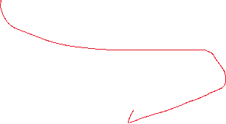

Int main (void){} 🡺 (void) mean that the function will take nothing , so when you call it you don’t write anything in carly braces , but in the second example we declare a variable (to be honest , it named argument ) that you receive it when you call the function , this argument you use it in the function code , pay attention => the argument that you write in {} isn’t the same the you write (see example) you can write anyother variable , because if it’s the same so the function will be used one time only .

void (the first one ) 🡺 main that the function will return nothing , you can not take the controll of nothing because it return nothing , so can’t save the value returnd by the function or add somthing to it or substrct or devide or .. (all operations on in ) , in this example , we tried to save the function in a varible but we get error because varialge save a value not a functions



The function is a place to save the code , we use function to avoid the repetition , instead of typing the code every time we call the function

The Main Fucntion

The Function

 #include <stdio.h>

 #include <cs50.h>

    int get_age(int X);

    int main (void){

    int age=get_int("enter you age : ");

    int days=get_age(age);

      printf("So , You live %i days and %i hours \n",days,get_age(age)*24);

    }

     int get_age(int X){

     return X*365;

 }

If we write the function under the main function and not above it , here we have to do a small declarition . The main fuction type is int Because by default it return 0 or 1 .

For make us able to take the control of the fuction , the function must return to us a value for can do operation on it and save it in a variabe , see this example :

 #include <stdio.h>

 #include <cs50.h>

   int get_age(int X){

     return X*365;

   }

    int main (void){

    int age=get_int("enter you age : ");

    int days=get_age(age);

    int hours=get_age(age)*24;

      printf("So , You live %i days and %i hours \n",days,hours);

    }

Here we declare the type of the value return by the function , which mean the type of the function as a value (value return = function)

** NOTE : if the value return is float so we have to save the value returnd from the function int float variable (this applied on all the other types) .

We declare the return value at the end of the function, if we write a code after it , it will not be readed .

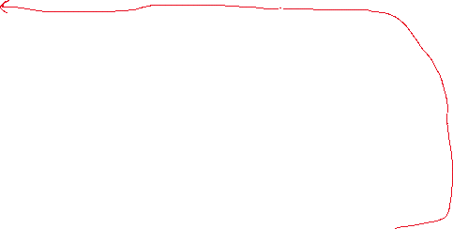

*Returned value 🡺 type : int*



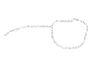

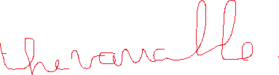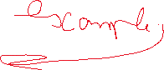

**#include <stdio.h>**

**#include <cs50.h>**

**void get_age(int X){**

**printf("you live %i days \n", X*365 );**

**}**

**int main (void){**

**int Years =get_int("enter you age : ");**

**get_age(Years);**

**}**

The fuction will not return anything

The fuction name is Hello

The function will not take anyting, so we have to write nothing in {}



**This is function**

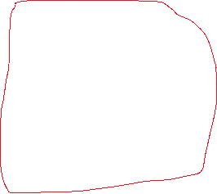

**#include <stdio.h>**

**#include <cs50.h>**

**void hello(void){**

**printf("Hello,world ");**

**printf("Hello,world ");**

**printf("Hello,world ");**

**printf("\n");**

**}**

**int main (void){**

**//call the function**

**hello();**

**}**